**A Study on the Performance of LoRa in a Rural Environment: Connectivity and Range Evaluation**

Nahshon Mokuaa and Ciira Mainaa

aSchool of Engineering, Dedan Kimathi University of Technology, Private Bag - 10143, Nyeri, Kenya.

a[nahshonmokua@gmail.com](mailto:nahshonmokua@gmail.com)

***Abstract***

Low-power wide-area networks (LPWAN) are gaining the attention of industry due to their potential applications in the automotive industry, smart metering, and smart home systems, among others. There are several competing technologies in the market, including Sigfox, LoRa, and Weightless. The main features of LPWAN Technologies are low consumption of power, low transceiver chip cost, and broad coverage. The two previous features are easier to achieve. This study focuses on connectivity and range evaluation. LoRa technology was used, and a set of real-life experiments were conducted using commercially available hardware. Three (3) battery-powered mobile stations (nodes) located on the ground (attached on a 2.5m tall stands) reporting their data to a base station (gateway), were used to obtain RSSI measurements for ten (10) test locations stations. In an area similar to the chosen station of study (Dedan Kimathi University of Technology), within a range of 1km, the results obtained will be used to develop a channel attenuation model that can be used for estimation of the connectivity and range of operation in the 868 MHz ISM band.

**Keywords:** *LPWANs, WSNs, LoRa, connectivity, range, RSSI, channel attenuation model*

# **INTRODUCTION**

## **Background**

There has been an increasing interest in the industry towards the low power wide area networks (LPWANs) [1]. Several competing technology providers, including Sigfox [2], which has covered many countries, including Kenya, operates as a technology and service provider for LPWANs, are pushing their products into the global markets at a time. Long-range (LoRa) alliance [3] is another competitor in the same field, which was officially established in Mobile World Congress 2015, as well as the Weightless special interest group [4]. These organizations have a readily standardized or about to be standardized technology of their own. Moreover, there is the introduction of optimizations on the devices' cost, the lifetime of the batteries used, as well as the range of coverage. However, there are lower data rates as a result of lower bandwidth, longer paging times, and reduced transmit power.

Nonetheless, WSNs are benefiting from profound worldwide standards with many vendors and operators, with robust and reliable working features products. The automotive industry (fleet management, vehicle to infrastructure communication, smart traffic, real-time traffic information to the vehicle, security and incident alerts and reporting); smart metering (e.g., electricity, water and gas consumption monitoring, medical metering and alerts); and smart homes (e.g., thermostat control and security systems) are some of the significant applications anticipated for LPWANs [5] [6].

Despite the traditional wireless sensor networks (WSN) and LPWAN having much in common, mainly in terms of network requirements and devices, their approaches have significant critical differences. Firstly, while the traditional WSN employs mesh or ad-hoc topology, the current LPWAN technologies require setting up the base stations (concentrator/gateway) to serve the end-devices. The latter communicates to the base stations only by forming around them a star network. Having a base station makes it efficient for network configurations. This way, the nodes are made simple and sufficiently affordable for mass production. Reaching the ten years lifetime can be made possible by limiting the number of messages sent each day by every node, even if the range of applications becomes naturally limited. Depending on the technology, the area of coverage of a base station may cover several kilometres, which is never a predetermined parameter.

## **Overview of LoRa**

For the Sigfox, LoRa, and Weightless LPWAN technologies, the achievement of the long-range of communication is by use of the sub-GHz radio bands and meagre data rates to improve receiver sensitivity. Sigfox and Weightless utilize the ultra-narrow band radio signals [2] [3], thereby enabling designing highly sensitive radio receivers.

“Long Range,” initiated by LoRa, is a wireless communication system that is of long-range, promoted by the LoRa Alliance. The aim of this system is to be used in long-lived battery-powered devices, where the use of energy consumption is of utmost significance. LoRa modulation is a proprietary spread spectrum method grounded on chirp spread spectrum modulation that uses wideband linear frequency modulated pulses. Furthermore, LoRa can usually refer to two distinct layers, that is, a physical layer using the Chirp Spread Spectrum (CSS) [7] [8] radio modulation technique, and a Media Access Control (MAC) Layer protocol LoRa-Wide Area Network (LoRaWAN). There are three Classes of the LoRa MAC that conduct different functionalities [9]. There will be a presentation of a study and an experimental evaluation (of the proprietary parts of LoRa) in this paper to investigate whether the advertised performance of LoRa is observed practically.

* + 1. **Long Range Wide Area Network (LoRaWAN)**

LoRaWAN defines the communication protocol and architecture system. On the other hand, the long-range link of communication is determined by the physical layer of LoRa [10]. The lifetime of a node's battery, the capacity of network service quality number of applications served by network and security are greatly influenced by protocol and network architecture.

### **LoRa Network Architecture**

“A star-of-stars topology” is a typical LoRa network with the inclusion of three diverse types of devices [11], as shown in **Figure 1**. Information of other nodes is forwarded by individual end-nodes in a mesh network to widen the range of communication and the network’s cell size. Apart from increasing range, complexity is added, the capacity of network reduced, and the lifetime of battery reduced when information that is not relevant to nodes is received and forwarded by other nodes. When the connectivity of long-range is achieved, the star architecture of the long-range gets much sensible for the lifetime of battery preservation [10]. Hereafter is the elementary architecture of a LoRaWAN network: end-devices communicate with gateways using LoRaWAN. LoRaWAN frames are forwarded by gateways from devices to a network server over a backhaul interface with higher throughput, commonly Ethernet or 3G. Gateways are consequently just bidirectional relays, or protocol converters, with the network server being accountable for both decoding the packets sent by the devices and generating those that should be sent back to the devices.

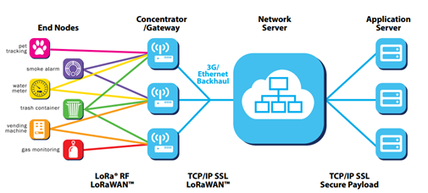

**Figure 1**: LoRa Network Architecture [10]

#### **Parameters of the Physical Layer and Network Capacity**

LoRa parameters available for customization of the LoRa modulation include the Bandwidth (BW), the Spreading Factor (SF), and the Code Rate (CR) [11]. The bandwidth is depended on by the chirp rate, which is equal to the bandwidth (one chirp per second per Hertz of bandwidth). Also, the symbol rate and bit rate are proportional to the frequency bandwidth at a given spreading factor; hence, a bandwidth doubling will effectively double the rate of transmission [12]. An increase of bandwidth lowers receiver sensitivity, while an increase of the spreading factor increases the sensitivity of the receiver. **Table 1** below illustrates this.

**Table 1**: Semtech LoRa receiver sensitivity in dBm at different bandwidths and spreading factors, taken from [11].

|  |  |  |  |  |  |  |
| --- | --- | --- | --- | --- | --- | --- |
| **SF**  **BW** | **7** | **8** | **9** | **10** | **11** | **12** |
| **125kHz** | -123 | -126 | -129 | -132 | -133 | -136 |
| **250 kHz** | -120 | -123 | -125 | -128 | -130 | -133 |
| **500 kHz** | -116 | -119 | -122 | -125 | -128 | -130 |

Network capacity is critically affected by the sum of concurrent channels, rate of data (time on-air), length of the payload, and the number of times there is transmission by nodes. Signals are typically orthogonal to each other when there is the utilisation of different spreading factors because LoRa is a modulation that has a spread spectrum base. The effective data rate changes when the spreading factor changes, and this is what is known as the adoptive data range, which also makes the battery lifetime of a node optimum [10].

## **Statement of Purpose**

A few articles related to LoRa have been evident in the literature. Petajajarvi et al. [9] studied the LoRa coverage and proposed a model of channel attenuation for use in the University of Oulu, Finland. There is a comparison of different long-range technologies, including LoRa, in [1] [13]. In [11], the authors analysed the LoRa capacity, and in support of multi-hop communications, they proposed LoRaBlink. The aim of this paper is two-fold: (i) To conduct performance experiments on LoRa connectivity and range evaluation for wireless sensor networks; (ii) to present and discuss the results obtained in regards to connectivity and range evaluation; The arrangement of the remaining part of this paper is as follows: **Section 2** provides methods deployed during experimentation, **Section 3** describes and analyses in detail and provides experimental performance studies presenting the evaluation for LoRaWAN. The conclusion is described in **Section 4** and then the acknowledgement as the last section of this paper.

# **METHODS**

## **Measurement Setup**

Measurements took place at Dedan Kimathi University of Technology, Central Kenya, 2019, during three (3) days at different times of the day. The university is located in a rural area, and the highest residential buildings are six (5) floors high. The area has an irregular terrain, with notable differences in geographical elevation. The base station was fixed all through the measurements. End devices that were sending payloads to the base station periodically were deployed at different locations away from the base station, 100m apart, in a range of 1km path along a line of sight (LoS) from a 2.5m stand node, as shown in **Figure 2**. In every payload transmitted, there was a measure of the Received Signal Strength (RSSI), which is used in the connectivity and range of evaluation studies hereof.

### ***Base Station***

Configuration and installation of The LoRaWAN Industry gateway (based on the MultiTech Conduit) at the Dedan Kimathi University of Technology on the roof of a building located centrally at an approximate height of 25 meters above the ground was used. It is a quick-to-deploy and simple-to-scale, programmable gateway designed for the Internet of Things (IoT). It is the most configurable, manageable and scalable gateway of communication for applications of IoT in the industry. Besides, it is suitable for LoRaWAN projects, both public and private. Warehouses, retail units and factories with options of external connectivity of antenna are covered extensively. There is a provision of exceptional range and performance by the industry gateway, and in this way, thousands of IoT assets are connected over networks of LoRaWAN. It can be installed in a desktop and mounting this kind of system package on a surface is possible or even mounting on a wall to extend coverage with an enclosure of rugged metal [14]. **Tables 2** and **3** summarize the specifications and operations of the gateway.

### ***End Device***

Our end-device was an STM32 Nucleo board [15], which was equipped with a LoRaWAN Transceiver Shield. During the measurements, the nodes were powered by 9V batteries. The transmit power was +14 dBm at a frequency of 868MHz. For on-ground measurements, the node was attached to a stand, as shown in **Figure 3**, approximately 2.5 m height of the ground.

There was a registration of each device on The Things Network (TTN) platform, which forwards data to the database for storage after retrieving it from the device. The security of data transmission is ensured by TTN, which provides credentials for device authentication. Each node periodically transmitted a payload, including the received signal strength (RSSI to the base station during measurements. There were no delivery control and automatic retransmissions mechanisms used. Payloads were sent for every 60 seconds for one hour in each Test Location.

# **RESULTS AND DISCUSSION**

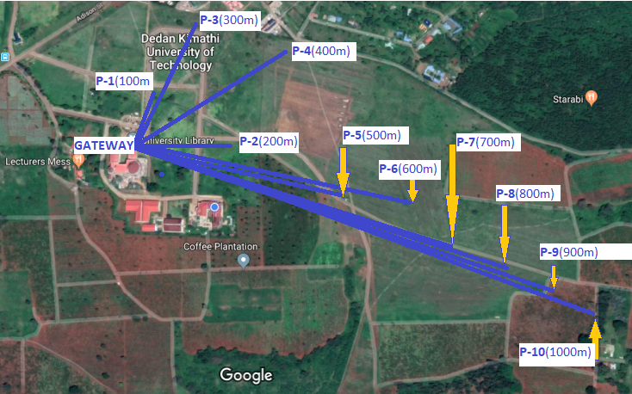

**Figure 2**: Test Points Geographical Locations. [Extracted from Google Maps]

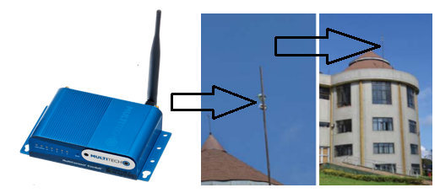

**Figure 3:** The LoRaWAN Industry gateway (based on the MultiTech Conduit)

**Table 2:** The LoRaWAN Industry gateway specifications (subject to environmental factors and placement of nodes/sensors and gateways) taken from [15]

|  |  |  |
| --- | --- | --- |
| Antenna | LoRa Female SMA, Cell 2dBi | 27dBm max output |
| Connectivity | Ethernet (RJ45) | Optimal 3FF Micro SIM |
| Enclosure | Size (161 mm by 107mm by 42mm) | Weight 1.45kg |

**Table 3**: The LoRaWAN Industry gateway operation (subject to environmental factors and placement of nodes/sensors and gateways) taken from [15]

|  |  |  |
| --- | --- | --- |
| Operating Temperature | Min: -30 °C | Max: +70 ℃ |
| Communicating Range | Line of sight(*Antenna): 20kms | Urban: up to 3kms |
| Installation | Wall or Desktop mount | Power 9V UK/EU |

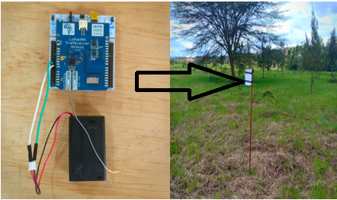

**Figure 4:** STM32 Nucleo board, equipped with a LoRaWAN Transceiver Shield.

**The Received Signal Strength Indication (RSSI)**

This refers to the signal power that is received in Milliwatts, and it is measured in dBm. How clear a receiver can “hear” from a sender can be measured using this value. Received signal strength indication, i.e., RSSI, is usually a negative value; hence, the signal is better when it is more positive (closer to 0). The value ranges of typical LoRa RSSI is -120 dBm to -30dBm.

For our experiments, we computed the mean RSSI for each of the 10 test locations that were used. At 100m away from the gateway, a mean strength of -102.7 dBm was recorded, while at 200m, the mean signal strength was -106.5 dBm. A complete record of the computed mean RSSI values for every test location is shown in **Table 4**. The best strength was realized at test location 3 (300m), while it notable that this value decrease (worsens) as we moved to test locations far away from the gateway, as depicted by **Table 4.**

**Table 4:** The Mean RSSI (in dBm) for the Ten (10) Test Locations

|  |  |  |  |  |  |  |  |  |  |  |
| --- | --- | --- | --- | --- | --- | --- | --- | --- | --- | --- |
| **Test Location (m)** | 100 | 200 | 300 | 400 | 500 | 600 | 700 | 800 | 900 | 1000 |
| **Mean RSSI (dBm)** | -102.7 | -106.5 | -96.3 | -100.5 | -109.6 | -108.2 | -111.9 | -112.2 | -112.2 | -113.1 |

The Whisker and Box Plots in **Figure 6** provides a quick graphical examination of the RSSI for each of ten (10) data sets. Outlier RSSIs were realized in test locations 3, 4, 8, and 9 and they are plotted as individual points. The highest notable degree of dispersion (spread) and skewness in the RSSI is easily observed with test locations 1, 2, 4 and 5, whereas test location 8 depicts the contrary. There is a general non-linear variation of the median positions of the RSSI, usually determined by various parameters, which include free space attenuation, shadowing, reflection and transmission, diffraction, among others. Considering these, with further experiments, a propagation model can be developed in the future.

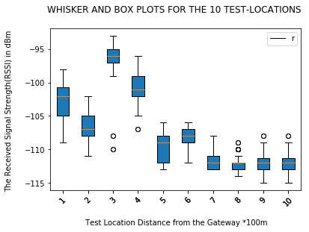

**Figure 6**: The Received Strength Whisker and Box Plots for the 10 Test Locations.

# **CONCLUSION**

# Different technologies of LPWAN are currently striving to come out as the best at the expense of their opponents and thus provide the world’s required massive connectivity. For communication to be achieved, there has to be a connection of objects through the wireless network. LoRa, the most prominent LPWAN technology, is focused on in this paper.

The reported results of the measurements show that on the ground on the distance up to 1 km, the amount of successfully attained RSSI within a 1km range ensures favourable connectivity. The results obtained will be used to develop a model that can be used by the Dedan Kimathi University of Technology fraternity to design LoRa-based application systems. However, this is within a range of 1km away from the location of the gateway. We were limited to 1km LoS (2.5m tall mobile station) due to a relatively lower height of the gateway since the test area has a relatively rugged terrain.

In the future, we plan to compare carry more experiments in regards to distance and non-line of sight (NLoS) and obtain much data for a comprehensive channel attenuation model. Moreover, we suggest that the gateway will be installed to a much high height for improved LoS coverage. Furthermore, with the expected availability of other LPWAN radio solutions, similar measurements will be conducted for comparison of their performance and results with those acquired for LoRa.

# **ACKNOWLEDGMENT**

First and foremost, we would like to thank the Almighty God for giving us good health during the entire period of this research. We wish to acknowledge the efforts of a particular group of individuals who have contributed to the development of this project, especially in data collection, for their ideas, support, and contributions in various. We would also wish to acknowledge the material support of the Dedan Kimathi University of Technology for this research. We also thank our friends and colleagues for their support throughout the entire period.

# **References**

|  |  |
| --- | --- |
| [1] | M. Centenaro, L. Vangelista, A. Zanella and M. Zorzi, “Long-range communications in unlicensed bands: the rising stars in the IoT and smart city scenarios,” *IEEE Wireless Communications,* vol. 23, no. 5, pp. 60-67, 2016. |
| [2] | “Sigfox.com,” Sigfox - The Global Communications Service Provider for the Internet of Things (IoT), [Online]. Available: http://www.sigfox.com/en/. [Accessed 01 November 2019]. |
| [3] | “Lora-alliance.org,” Home page | LoRa Alliance™, [Online]. Available: https://www.lora-alliance.org/. [Accessed 02 November 2019]. |
| [4] | “Weightless.org,” Weightless - Setting the Standard for IoT, [Online]. Available: http://www.weightless.org/. [Accessed 02 November 2019]. |
| [5] | “GSA,” Nokia - LTE M2M: Optimizing LTE for the Internet of Things - GSA, [Online]. Available: https://gsacom.com/paper/nokia-lte-m2m-optimizing-lte-for-the-internet-of-things/. [Accessed 03 November 2019]. |
| [6] | S. Andreevy, O. Galinina, A. Pyattaev, M. Gerasimenko, T. Tirronen, J. Torsner, J. Sachs, M. Dohler and Y. Koucheryavy, “Understanding the IoT connectivity landscape: a contemporary M2M radio technology roadmap,” *IEEE Communications Magazine,* vol. 53, no. 9, pp. 32-40, 2015. |
| [7] | A. Berni and W. Gregg, “On the Utility of Chirp Modulation for Digital Signaling,” *IEEE Transactions on Communications,* vol. 21, no. 6, pp. 748-751, 1973. |
| [8] | A. Springer, W. Gugler, M. Huemer, L. Reindl, C. C. W. Ruppel and R. Weigel, “A wireless spread-spectrum communication system using SAW chirped delay lines,” *IEEE Transactions on Microwave Theory and Techniques,* vol. 49, no. 4, pp. 754-760, 2001. |
| [9] | J. Petäjäjärvi, K. Mikhaylov, A. Roivainen, T. Hänninen and M. Pettissalo, “On the coverage of LPWANs: Range evaluation and channel attenuation model for LoRa technology,” in *2015 14th International Conference on ITS Telecommunications (ITST)*, 2016. |
| [10] | “Lora-alliance.org,” What is LoRaWAN® | LoRa Alliance™, [Online]. Available: https://lora-alliance.org/resource-hub/what-lorawanr. [Accessed 05 November 2019]. |
| [11] | A. Augustin, J. Yi, T. Clausen and W. M. Townsley, “A Study of LoRa: Long Range & Low Power Networks for the Internet of Things,” *Sensors,* vol. 16, no. 9, p. 1466, 2016. |
| [12] | “Revspace.nl,” DecodingLora - RevSpace, [Online]. Available: https://revspace.nl/DecodingLora. [Accessed 03 November 2019]. |
| [13] | N. Rathod, P. Jain, R. Subramanian, S. Yawalkar and M. Sunkenapally, “Performance Analysis of Wireless Devices for a Campus-wide IoT Network,” in *The 2015 International Workshop on Wireless Network Measurements and Experimentation*, 2015. |
| [14] | “The Things Network,” MultiTech Conduit, [Online]. Available: https://www.thethingsnetwork.org/docs/gateways/multitech/. [Accessed 13 September 2019]. |
| [15] | “STMicroelectronics,” STM32 Nucleo Boards - STMicroelectronics, [Online]. Available: https://www.st.com/en/evaluation-tools/stm32-nucleo-boards.html. [Accessed 22 August 2019]. |